AGENDA  SPECIAL MEETING – CLOSED SESSION  sierra madre city council | Gene Goss, Mayor
 | Edward Garcia, Mayor Pro Tem
Rachelle Arizmendi, Council Member
Kelly Kriebs, Council Member
 | Robert Parkhurst, Council Member
 | Michael Amerio, City Treasurer
Tuesday, November 8, 2022
4:30 PM
Tuesday, November 8, 2022  4:30 PM | 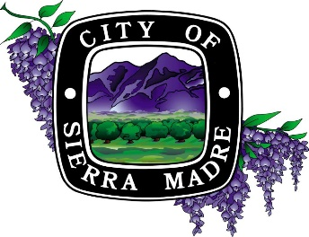
Sierra Madre City Hall
232 W. Sierra Madre Boulevard
Sierra Madre, California 91024
The Brown Act provides the public with an opportunity to make public comments at any public meeting; As an alternative to providing comments at an open session, the public comment may also provide comments by e-mail to PublicComment@CityofSierraMadre.com by 3:00PM on the day of the meeting. Emails will be acknowledged at the Council meeting and filed into public record.

CODE OF CONDUCT
The purpose of a City Council meeting is to conduct City business. Members of the public that behave in a manner that interrupts or obstructs the Council’s ability to conduct City business may be asked to leave the meeting. Any and all demonstrations which disrupt, interrupt, or obstruct the Council’s ability to conduct City business are prohibited. No signs, posters or other large objects shall be brought into the meeting place if doing so would disrupt, disturb or otherwise impede the orderly course of the meeting.

CLOSED SESSION
CALL TO ORDER/ROLL CALL |  | Mayor Goss, Mayor Pro Tem Garcia, Council Member Arizmendi, Council Member Kriebs, and Council Member Parkhurst
PUBLIC COMMENT Regarding Closed Session Items
CLOSED SESSION

RECESS TO CLOSED SESSION REGARDING:
- Existing Litigation:
Pursuant to G.C. 54956.9 (a)

Name of Case: Susan Neuhausen v. Laura Aguilar, in her official capacity as Acting City of Sierra Madre Clerk; Dear Logan, in his official capacity as the Registrar Recorder/County Clerk of the County of Los Angeles, California;and DOES 1 to 100, inclusive.

Case No. 228TCP03172

- Public Employee Performance Evalution:
Pursuant to G.C. 54957
Title: City Manager Jose Reynoso

- Public Employee Performance Evalution:
Pursuant to G.C. 54957
Title: City Attorney Aleks Giragosian

ACTION ITEMS
Regardless of staff recommendation on any agenda item, the City Council will consider such matters, including action to approve, conditionally approve, reject, or continue such item.
AVAILABILITY OF AGENDA MATERIALS
Materials related to items on this agenda are available for public inspection on the City’s website at www.cityofsierramadre.com.
MEETING ASSISTANCE
If you require special assistance to participate in this meeting, please call the City Clerk’s office at (626) 355-7135 at least 48 hours prior to the meeting.
ADJOURNMENT
The City Council will adjourn to a regular meeting to take place on November 8, 2022.

